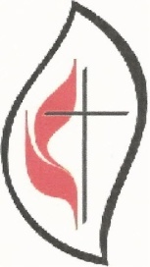FAITH . HOPE . LOVE IN ACTION

THE BALTIMORE-WASHINGTON CONFERENCE
UNITED METHODIST WOMEN

VOLUME IV DECEMBER 2016

- - - - - - - - - - - - - - - - - - - - - - - - - - - - - - - - - - - - - - - - - - - - - - - - - - - - - - - - - - - - - - - -

MESSAGE FROM THE PRESIDENT
We give high praises to God for the success of the Baltimore-Washington Conference United Methodist Women’s’ Annual Celebration held on October 22, 2016. The winds of the Holy Spirit guided the flying kite of faith, hope and love in action among the gathering, as mission activities from the eight districts were showcased.
Allow me to express my appreciation for the hard work of the Conference team, district presidents and the local church units for your commitment to serving women, children and youth. We all are members of the body of Christ and we use our gifts and talents to serve others so that God can receive the glory.
We are called as women to seek justice in search of mercy, on behalf of women, children and youth to improve the quality of their lives. Our purpose is the hallmark of our work together. The mission is turning faith, hope and love into action.
In closing out 2016 please reflect on what you have accomplished for UMW. Kindly provide information on the following:
The district presidents are to evaluate their efforts on domestic violence and abuse, people with disabilities, charter for racial justice and maternal health for women.

President (Cont’d.)
Page 2
The leadership team is expected to evaluate your efforts related to your scope of responsibly on the team. Kindly submit requested information in writing before the end of December 2016, to the president and vice president.
The annual planning retreat and officer’s training is scheduled for Saturday,
January 7, 2017 at the conference center (10:00 a.m. for training and 12:30 p.m. for the conference leadership team retreat). All district officers are expected to be trained by the Conference team during the morning session. Please arrange your schedule to assure your presence as well. District Presidents, Conference Officers and anyone else staying for the planning retreat should please bring your lunch to this important meeting. Sweets and beverages will be provided.

For justice, Almighty God, you created us in your own image, grant us grace fearlessly to contend against evil, and to make no peace with oppression. And, that we may reverently use our freedom. Help us to employ it in the maintenance of justice to the glory of your name; through Jesus Christ our Savior, Amen (The Book of Common Prayer U.S.A., 20TH CENT., ALT)

Thank you for your commitment to the United Methodist Women. I wish you a Merry Christmas and a Prosperous New Year.
Respectfully submitted,
Elizabeth M. Stemley, President
estembly 1190@comcast.net

***************************************
VICE PRESIDENT
Greetings to all my United Methodist Women Sisters!
I hope this message finds you well, blessed, and looking forward to the upcoming holiday season when we can show our gratitude and thankfulness for our many blessings, and welcome our Lord and Savior again into this world on Christmas Day. Thank you, Jesus!
You are my blessing! Each and every one of you! So many of you came to celebrate together at our Conference UMW Annual Celebration at Towson UMC, approximately 180 of you, and you didn’t come empty-handed. No indeed! You donated bags and bags of handmade lap blankets which were delivered to the

Vice President (Cont’d.)
Page 3

Genesis Healthcare Center in Towson after our meeting. There were so many that the staff there said they would be able to share with other Genesis facilities. You
also donated bags and bags of handmade baby hats which were brought to St. Joseph’s Medical Center, Department of Pediatrics, in Towson. Many little ones will
have warm, cozy heads because of you! Last, but not least, you brought bags and bags of supplies and assembled close to 200 Birthing Kits which were brought to the Parkton Hub for distribution to those most in need.

Our celebration itself was a blessing to me and too many of you. It was a privilege to help in the procession of our Conference Kite which was first presented at our Northeastern Jurisdiction Celebration in Syracuse, NY this past June. We enjoyed hearing about the history of Towson UMC, presented by long-standing member, Sally Ransom Knecht. Our memorial service allowed us to show our gratitude for all of life’s blessings, and to remember and name our UMW Sisters who have gone on to be with the Lord. We heard from our local units and districts as they told their stories of how the work they were doing with our UMW initiatives impacted their communities. We experienced an amazing, unique, and spiritual Communion service led by Rev. Maidstone Mulenga, Assistant to the Bishop and Director of Connectional Ministries, Rev. Rod Miller, Lead Pastor of Towson UMC, and Rev. Margery Schammel, Assistant Pastor of Towson UMC. Our music we sang was uplifting, our business meeting informative, and the “I am a United Methodist Woman” presentation by Colleen Cates and Willa Kynard had us all laughing and clapping. Your new Conference UMW Slate of Officers was installed and are already preparing for events coming up in 2017. Last, but not least, the offering you gave will be applied to the Conference Pledge to Mission and will assist United Methodist Women in the National Office in New York City to provide funds for the numerous mission projects that we support, both nationally and globally.
I want to especially thank Gwendolyn Brooks, President of the Baltimore Metropolitan District UMW and her Leadership Team for the excellent job they did in hosting our Annual Celebration. Kudos also to Mrs. Carol Miller, wife of Pastor Rod
Miller, who went above and beyond to create a beautiful and welcoming environment for all of us. I also worked very closely with Kim Ayres, Business Manager, and Bob Ashby, Assistant Building Superintendent at Towson UMC. Without their efforts, this event could not have happened.
Our next Conference UMW event is coming up on Saturday, January 7, 2017, at the Conference Mission Center in Fulton, Maryland. All District Leadership Team officers are encouraged to attend District Training, which will begin with registration
and morning refreshments at 9:30 a.m., followed by training from 10:00 a.m. – 12:00 noon. After training, at 12:30 p.m. – 3:00 p.m., there will be a Conference UMW

Vice President (Cont’d.)
Page 4

Planning Retreat for the Conference Leadership Team and all District Presidents. All officers staying for the Retreat should bring their lunch. Beverages and snacks will be provided.

May the Son of God enfold you with His spirit and His love!
In His Service,
Linda S. Yost
Vice President
LJYost@verizon.net
***********************************************

SECRETARY
Thank you, secretaries for the vital role you perform in recording the actions and history of our marvelous organization! It has been my honor to have served as the secretary of the Baltimore-Washington Conference United Methodist Women for the past two years. I have enjoyed meeting and working with district and local secretaries from across our conference. Local secretaries, you should send district secretaries your officer lists. District secretaries, please remember to send me the updated list of your district elected officers. The list should also include contact information. If you are leaving your position, prepare all information that you acquired from previous secretaries and your minutes to pass on to the new secretary. I would like to welcome Sherie Koob as the new BWC UMW secretary. In January, I will begin serving as the new Spiritual Growth Coordinator for the Conference replacing Zilpha Pinkney whose four year has ended.

Secretary (Cont’d.)
Page 5

Note, the Conference is having training for all district officers on January 7, 2017 at the BWC Mission Center. Hope to see you again at that gathering.

As we prepare to celebrate the joy we share in the birth of our Lord and Savior Jesus Christ, I pray you will also reflect on the blessings of 2016.
Remember to share that joy with others.
Merry Christmas,
Rita Green, Secretary
ritamgreen@hotmail.com
***************************************************

SPIRITUAL GROWTH
This is my last article as the Spiritual Growth coordinator and I would like to thank all of you for your support and help. I have grown tremendously in my faith and will continue to keep all of you lifted up in my prayers. There is still plenty of room for growth and I ask that you keep me in your prayers. May God continue to BLESS AND KEEP YOU ALL. The page below was taken from “3-Minute Devotions for Women, published by Barbour Publishing, Inc. Used by permission.”
LEAD, FOLLOW, AND BLESS
You go before me and follow me. You place your hand of blessing on my head.
PSALM 139:5 NLT
A kindergarten teacher explained the rules to her new students. “When we walk down the hall,” she said, “I will always go first, and you must not pass me.” Immediately the children asked why. She told them she would be their guide to help them know which way to go. She added that it would help her keep track of them. “I don’t want to tell your parents that I lost for you when they come for you!” she teased. The teacher would go before her students.

The Admiral of a ship took a crew of Navy recruits on board. He covered standard procedures of the ship. “If the ship goes down,” he said, “get the life rafts and save yourselves. I will come behind you. Once I know that all of you are safe, I will follow.” The captain would follow his sailors.

Spiritual Growth (Cont’d.)
Page 6

A young mother tucked her daughter into bed. The child mumbled sleepily, “Mommy, why do you put your hand on my head before you leave my bedroom?” The smiling mother answered, “I place my hand on your head as I pray for you, sweetie. I ask God’s blessing on you as you sleep.” The mother placed her hand upon the head of her child.
God is all three. He leads you. He follows you. He places a hand of blessing upon your head. An omnipresent Father has you in His care.
God, thank you that you lead me, have my back, and bless me daily. Amen.
Zilpha Pinkney,
Spiritual Growth Coordinator
************************************************************
SOCIAL ACTION

Sisters in Christ,
With the recent election of Donald Trump as President of our country, I think we who are Christians and believers in God’s rule of love and justice for all – immigrants, women, and people of color – will have a great challenge before us in the next few years. We pray for President-elect Trump, that God will give him wisdom and compassion, but we must be ready to work harder for the environment and human rights if his policies threaten those rights and our earth.
One of our concerns right now is ending gun violence, led by General Board of Church and Society advocate, Beth Reilly breilly@umc-gbcs.org. Consider showing the film “Living for 32” at your church and having a discussion about the new UMC Resolution for ending gun violence and UMC suggestions for action.
Social Action (Cont’d.)
Page 7

Another one of our priorities is maternal health and gender violence. Watch for opportunities to bring these concerns to your congregations. GBCS recently had a webinar on this subject, open to all, and both GBCS and UMW have materials you can use.
Our environment and climate change is at a critical point. Does your church have a Green Team? What can you do to help preserve our earth for the next generation?
The lives and rights of our immigrants are being challenged right now. Speak out on behalf of them.
In addition, racial and criminal justice are principles for which we must be ready to act. As Christians and as Americans these principles are part of who we are. Let’s show determination to make them part of reality.
At this critical time in our nation and our world, as children of God, we are all called on to do what we can.
May God give us wisdom, courage and energy to act.
Judy Smith
Social Action Coordinator
202-882-3021
smarmayor@aol.com

Page 8
EDUCATION AND INTERPRETATION
As we approach the end of 2016, it is great to know that we are living the Vision of United Methodist Women, which is “…turning faith, hope and love into action on behalf of women, children and youth in the world.” As we look to 2017, let us renew our efforts in this wonderful tradition while continuing our engaging work in this arena.
Hands-On Mission: We applaud our B-W Conference districts and local units for the enlightening hands-on Mission reports provided during our Conference Annual Celebration! All are to be congratulated for your work as we continue our efforts to “expand concepts of mission” in keeping with the United Methodist Women’s Purpose.
District Mission Today Unit Competition: Kudos and congratulations are in order for our three winning districts in the Mission Today Unit Competition! First, a hearty thank you to the local units that qualified for certification under the Mission Today Checklist program, which also served to support district participation in the Mission Today Competition. The winning districts respectively are: First Place, Washington East District (again, for a second year, WOW!); Second Place, Greater Washington District: and Third Place, the Annapolis District. The Washington East District holds the rotating Crystal Award again this year, but remember that in the spirit of friendly competition, your district can challenge this. The 2017 race is ON!
Mission Today Unit Checklist Performance: Based on data provided with 2016 Mission Today Unit Competition submissions, there are about 350 local UMW Units within our Conference. About 60 local units qualified for certification at Gold, Silver, and Bronze levels this year. A few others may have qualified had their total 2016 Pledge to Mission funds been submitted by the end of the competition. We encourage each local unit and district to begin now to support local unit certification under the Checklist Program. We know that many wonderful Mission activities are taking place in your areas. We urge you to begin 2017 with the Checklist at your fingertips as you engage in the Mission outreach which is so characteristic of our B-W Conference UMW units.
Looking Ahead to 2017:
Mission Giving: Monies received in support of UMW Mission activities are realized through our Mission giving. An important focus of this emphasis is the Pledge to Mission through which women prayerfully make pledges through their local units and districts. Pledges designated for Mission are sent forward and

Education & Interpretation (Cont’d.)
Page 9

budgeted for ministries with women, youth and children around the world. If you have not already done so at the local unit level, you are encouraged to develop a realistic Pledge to Mission for 2017, then work to ensure that your pledged amount is submitted within the designated timeframe.
Is Planning for an Ubuntu Journey in 2017 in Your Future? Ubuntu, an African word, has been translated as, “I am human because you are human.” Opportunities abound for participation in mission activities under this umbrella at all levels within this country and internationally. Visit this website – www.unitedmethodistwomen.org/Ubuntu - to obtain in-depth information, an Ubuntu Toolkit, and information on three international journeys planned for 2017 in Columbia, Mozambique, and Portugal in April, July, and September, respectively. Sounds like lots of fun!
“…and let us run with perseverance the race that is set before us…” Hebrews 12:1
Ann Price
Education and Interpretation Coordinator
pricefa@verizon.net

Page 10

MEMBERSHIP NURTURE & OUTREACH

"O Lord, let your ear be attentive to the prayer of your servant,
and to the prayer of your servants who delight to fear your name,
and give success to your servant today, and grant him mercy ..."
Nehemiah 1:11

Greetings and Happy Thanksgiving, again it is that time of the year that we begin the process of reporting the membership count. The 2016 membership count will be done electronically through a link on the United Methodist Women website, at www.unitedmethodistwomen.org. Each member is encouraged to access the myUMW -Members icon (a blue box) and complete the information.

Additionally, each unit will report membership information on-line by accessing the icon CENSUS 2016: Presidents (a magenta box) for their local unit. There are several videos listed on the page that are informative about the process on the United Methodist Women website.

BE COUNTED!! We will continue working for justice and peace and to ensure that the United Methodist Women will be around another 150 years. We are important to women, children, youth and the world. We need to continue work to increase and retain members throughout the Baltimore-Washington Conference United Methodist Women.

Peace and Joy as we work to fulfill our PURPOSE.

Daphne L. Hurd
Membership Nurture and Outreach Coordinator
daphnelhurd@icloud.com

Page 11
COMMUNICATIONS
KEEPING PEACE WITH OTHERS
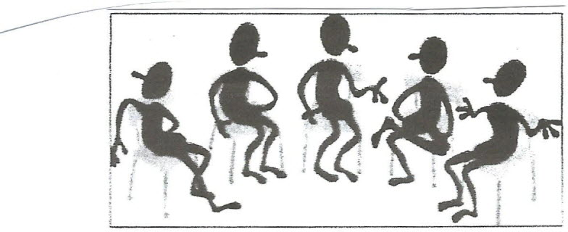
- Don’t try to change others. It is a mistake to try to fit another individual into a mold. Accept others for who they are.
- Don’t publicly criticize others or correct them with words or facial expressions. It is a delusion to think that one can achieve anything by crushing another.
- Develop a good sense of humor. Don’t be too serious about yourself. If you can look objectively at yourself and laugh when the joke is on you, you’ll be able to get along with anyone.
- Don’t keep harping on the small faults of others, particularly those in your own family. Most quarrels concern only trivial things, not of sufficient importance to disturb the peace.
- Be tolerant. Realize that the habits, customs, speech and outlook of others are different from your own.
- Realize that others are entitled to their viewpoint. We don’t need to agree with them but if we state our own views, we should do so politely.
- Watch our tone of voice. Your tone reveals your attitude, your respect for others. An aggressive tone belittles. A quiet tone invites further thoughts on the issue.
- Be an attentive listener. Show interest.
- Develop a habit of reading and studying. You’ll be amazed how this will broaden your mind and make you more tolerant.
- See Christ in others and let others see Christ in you.
Gertrude White
Communications Coordinator
trudytil@aol.com

Page 12
SECRETARY OF PROGRAM RESOURCES
Congratulations again to all the participants in the Reading Program. There were over 60 participants.
The list for the Reading Program 2017 explores global Christianity, intellectual, spiritual leadership, self-healing, community healing, and issues we face today. I look forward to more units getting involved in the Reading Program. Let’s increase the list for next year. Continue to read, pray, and act.
Have a Blessed and Prosperous Holiday, and New Year.
Pamela Randall
Pamelaarandall53@yahoo.com
************************************************************
BWC-UMW
BOARD OF TRUSTEES
I am pleased to announce that all the districts in the Baltimore Washington Conference Board of Trustees are represented. Thank you Margaret Pennington from Cumberland MD, for making our Board complete.

2016 is my last year on the Board and Geraldine Whitley will be the new President of the Board of Trustees. I have enjoyed many committees that I have served on but I can honestly say that working with the Board of Trustees has given me more knowledge than anything else that I have been a part of. Rosetta Daniels will represent the Washington East District and I am confident that she will do an excellent job.
Susan Howes
President
showes@chesapeake.net

Page 13

2016 SCHOLARSHIP RECIPIENTS

Miranda | Mossburg
Caroline | Strakonsky
Jennifer | Shepheard
Tierra | Baker
Katlin | Bagdovitz
Kelsey | Day
Amelia | Baker
Alexis | Duncan
Tanya | Cooper-Johnson
Jordan | Betters
Mary | Cole
Sarah | Bair
Elizabeth | Howard
Rebecca | Selvaraj
Cierra | Beatty

Pamela Randall
Scholarship committee

Page 14

LEGACY REPORT
To Women of God,
We continue to keep it moving, making a difference in the lives of women, children and youth in the Baltimore-Washington Conference. We are on target for our giving to the Legacy fund.

I am so excited about the young women who have stepped forward to carry on the mission of the United Methodist Women. We will continue to mentor, support and encourage them so that they will continue fanning the flame of God’s gift that is within them to spread like wild fire to others.

So please join them on December 10, 2016 at the Conference Center in Fulton, MD
to experience their vision. I am sure you will be delighted, have fun, get the word, and enjoy the food as well as a unique Fellowship time with the women of God.
On September 16, 2017, please join us for a GALA evening of fun, music and other entertainment. More information to follow.
Please submit your articles for the journal by December 31, 2016. A draft format is available.
- 2018 to follow with fashion show and cultural events.
- 2019 Cruise to the Islands (to be determined).

So please join the Legacy Team as we continue to support the Legacy of the Women who have gone before. These women left the funds and resources so that we could continue the missions of the United Methodist Women.
Thanks
Daisy Farmer, Legacy Liaison, UMW
Farmerdaisy66@gmail.com

Page 15
FROM THE ANNAPOLIS DISTRICT
It is hard to believe that 2016 is almost over. However, this has been another successful year for the Annapolis District UMW. I am so proud of all of you and the mission projects that you have pursued and completed with Faith, Hope and Love in Action!
Many thanks to my entire UMW sister for the support and love shown during the five month illness and passing of my mother, Alice “Evelyn” Jones. The love that I felt was immeasurable and made me even prouder to be a member of the United Methodist Women. Thanks so much and love to all of you.
Our annual meeting was held on October 8th at Nichols-Bethel UMC and our guest speaker was Linda Yost. Linda, who is the Vice President of the Baltimore-Washington Conference UMW, conducted an excellent presentation on Climate Change.
Thanks to all of the women who brought baby items for the Emergency Baby Pantry at Food Link and thanks to the women of Nichols-Bethel UMW who were gracious hostesses who prepared us a delicious continental breakfast.
The Baltimore-Washington UMW sponsored trip to NYC is coming up this weekend. I am so looking forward to spending time with my UMW sisters and studying Mass Incarceration. The UN Seminar is a highlight of every year and so enlightening.
Please plan to attend the 150th Legacy Committee UniTea Brunch and Social on Saturday, December 10 at 11 a.m. It will be at the Baltimore-Washington UMC Conference Center in Fulton, MD. This is an opportunity to bring younger women from your church and to get them interested in UMW. A flyer with all of the details of the event are included in this edition of The Flame.
The Annapolis District Officer Training will take place on Saturday, January 14, 2017 at Baldwin Memorial UMC. It will be hosted by the UMW of John Wesley Waterbury UMC. All local UMW officers and any members interested in learning more about the UMW are invited to attend. Hope to see you there!
Happy Thanksgiving and Merry Christmas!
In God’s Love,
Janice Crowe, President
Janice.a.crowe@comcast.net

Page 16
BALTIMORE METROPOLITAN DISTRICT
The Baltimore Metropolitan District continues to move forward in our quest to be a blessing to women, youth and children through mission. On September 3, 2016, we met with St. Paul Praise and Worship to help restart their unit. Everyone was pleased and excited to get started. We continue to work with several other new and restarted units and we ask for your continued prayers in this endeavor.

Our Annual fall meeting was held on September 17, 2016 at John Wesley UMC with great attendance. We were blessed by the “Next Generation” liturgical dancers of John Wesley UMC. A donation was collected for the 150-Year Legacy Fund in memory of Delores Chambers our spiritual growth person who transitioned earlier this year. All officers were installed with the exception of a treasurer and communications coordinator. Please be in prayer for our district as we search for and secure qualified women to fill these positions.

The Baltimore- Washington Conference held the Conference Annual Celebration meeting at Towson UMC. The Baltimore Metropolitan District hosted what turned out to be a spectacular affair. We anticipated one hundred attendees, but praise the Lord, there were more than 180 in attendance. We had to send out for more lunches. On behalf of our district I want to thank everyone who made lap blankets, which were taken to Genesis Health Care on York Rd. and for the baby hats which were
taken to St. Joseph Hospital. Both facilities were pleased and excited by the amount of blankets and hats we delivered. Also, approximately 200 birthing kits were assembled after lunch and were taken to the Parkton Hub for national and global distribution to areas of greatest need. Thank you for your generosity.

As we enter the holiday season, I bring you warmest wishes from the Baltimore-Metropolitan District. May you each enjoy a bountiful Thanksgiving, a joyous Christmas season, a blessed and healthful New Year.
Love and blessings,
Gwendolyn Brooks, President
gwndlynbrooks@aol.com

Page 17
BALTIMORE SUBURBAN DISTRICT
The women of the Baltimore Suburban District are grateful we could serve others within the community, the state and the nation this past year. We boldly set out to reach women, children, youth and the needy to better their circumstances. We pray that in 2017, God will give us endurance, and a spirit of unity as we follow Christ Jesus in carrying out missions throughout the year.
We offer a “Message of Hope” as found in Ezekiel 36:24-29. “For I will take you out of the nations; I will gather you from all the countries and bring you back into your own land. 25 I will sprinkle clean water on you, and you will be clean; I will cleanse you from all your impurities and from all your idols. 26 I will give you a new heart
and put a new spirit in you; I will remove from you your heart of stone and give you a heart of flesh. 27 And I will put my Spirit in you and move you to follow my decrees
and be careful to keep my laws. 28 Then you will live in the land I gave your ancestors; you will be my people, and I will be your God. 21 I will save you from all your uncleanness. I will call for the grain and make it plentiful and will not bring famine upon you.”
God promises physical and spiritual healing and restoration for his people. God does this out of his love for us. As United Methodist women, we are guided by our faithfulness, known for our kindness, identified by our integrity, thankful for the protection of God, and grateful for our prosperity and blessings. With one heart, we will strive to glorify God with the work we do as we, along with others in the faith, wait on the promises of God.
Respectfully submitted,

Ruthella Lievers, President
Ralievers1@comcast.net

Page 18
CENTRAL MARYLAND DISTRICT

ENGAGING NEW TEAM MEMBERS AND PLANNING FOR SUCCESS IN 2017

Greetings and blessings to you from the Leadership Team of the Central Maryland District (CMD) of the United Methodist Women!
As dedicated women of God and sisters in the UMW circle, we are excited about the sweeping changes and plans He is orchestrating in our District!
First, six continuing (Sarah Utz, Laura Jane Copeland, Mary Jefferson, Doris Watts, Cheryl Gooden and Edna Johnson) and three new officers ( Dianna Woodlon – Vice President, Eliza Weeks - Treasurer, and myself), were installed at the CMD’s October 1st Annual Celebration hosted by our sister United Methodist Women from Wesley Freedom UMC in Sykesville, MD. Opened with remarks by District Superintendent, Rev. J. W. Park, and with a keynote message by Rev. Brian Jackson, the celebration was inspiring for all in its call to use our testimony for Christ to fuel our effectiveness in our service to God’s women, youth and children domestically and around the globe.
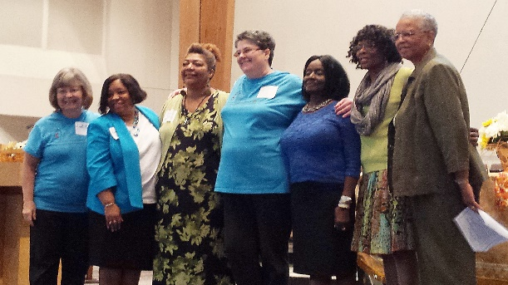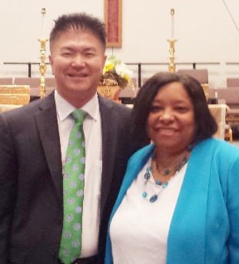

In a two-day retreat hosted by the CMD, at the United Methodist West River Center, the CMD Leadership Team and leaders from local units were charged and challenged with the call to, “Get Connected” - spiritually, as individuals, as units of the UMW and to the projects and priorities of the Conference and National UMW.
Colleen Cates, Board of Directors member, United Methodist Women National Office (pictured below in a red top with white logo on her left side with Conference Vice President, Linda Yost), joined the planning sessions and added tremendous value, perspective and enjoyment to the day.

Central Maryland (Cont’d.)
Page 19

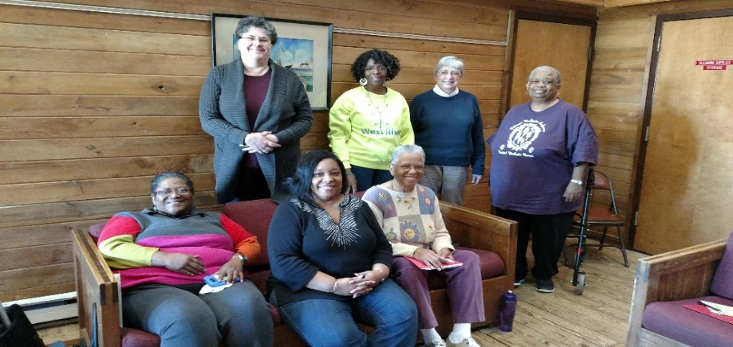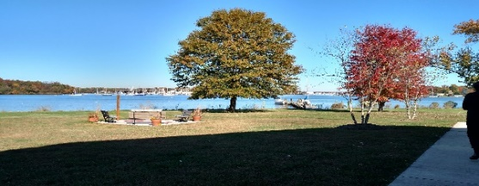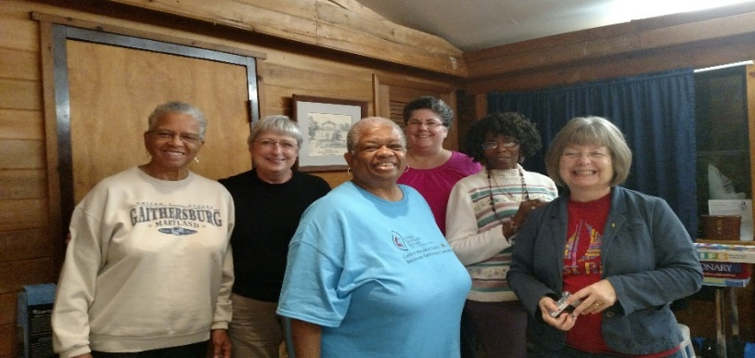

As a key Retreat outcome, the group formed a vision and is ready to kickoff upcoming 2017 as, “A Year of Advances in Engagement,” featuring the design and implementation of an “Engagement Toolkit” that will be the Leadership Team’s approach to connect and re-engage local units within our District. This tool will also be “rolled out” for use by our local units as they seek to engage new members and expand their home church’s participation in their mission work.
We are excited about all that God is doing through the women of the Central Maryland District, and we are grateful for the partnership of all of you who are in His Service.
We extend our warm regards and best wishes for a blessed Christmas season for you and your families, and we look forward to seeing you at a CMD meeting or event very soon in 2017!
Your Sister in Christ,

Tamara Hull, President
tahinspired@hotmail.com

Page 20
WASHINGTON EAST DISTRICT
Merry Christmas to everyone in the Baltimore- Washington Conference. It is a time to celebrate our Lord’s birth; a time for fellowship with our family and friends; a time to evaluate our year – the pluses and minuses; and a time to reflect on all the blessings our Lord has given us. We are thankful for the dark places that we have to walk through with anticipation of God bringing us into the light, with time.

On that note I want to share with you that the Washington East District won for the second year in a row the award for the most Mission Today units. Alice Jackson has done a great job with this and that is because she had great training by our former Education and Interpretation, Arlene Gross. This is a testament to the importance of our training that is available to us. Please remember that the district officers will be trained on January 7 at the Conference Center and then we will train our units on January 21 at Clinton United Methodist Church.
We have an awesome Leadership Team for 2017 including our new Treasurer, Linda Ford. We already have our Calendar for 2017 and it is chock-full of training and learning opportunities for each of us. My goal this year is to visit
every unit in the Washington East District within the next two years so I have asked each unit to send me their calendar. I want to thank you for allowing me to be your President over the last two years and I have learned so much and made so many friends within this organization. I had the pleasure of attending the Wesley Seminary Resource Center to share information with the upcoming ministers what the United Methodist Women are all about on November 15th. They offered a church service which was highly attended and each person had the opportunity to share their feelings in a word or two about the election last week. I could feel the healing process begin. No matter your feelings, remember to start with your locals and then move forward. Everyone has a voice. God is good and God is in Control.
Blessings to you all,
Susan Howes, President
shows@chesapeake.net

Page 21

THE TRUE MEANING OF CHRISTMAS

In today’s day and time, it’s easy to lose sight,
of the meaning of Christmas and one special night.

When we go shopping, we say “How much will it cost?”
Then the true meaning of Christmas, somehow becomes lost.

Amidst the tinsel, glitter and ribbons of gold,
we forget about the child, born on a night so cold.

The children look for Santa in his big, red sleigh never thinking of the baby whose bed was made of hay.

In reality when we look into the night sky we don’t see a sleigh
but a star, burning bright and high.

A faithful reminder, of that night so long ago,
and of the child we call Jesus, whose love, the world would know.

Author ---Brian K. Walters

Merry Christmas & Happy New Year from the
Baltimore-Washington UMW Leadership Team

