**of the**

**Baltimore-Washington Conference, United Methodist Women**

**Expanding Concepts of Mission at Wesley Theological Seminary**

**ANNUAL SPRING LUNCHEON**

**Sponsored by the United Methodist Women of the**

**Greater Washington and the Washington East Districts**

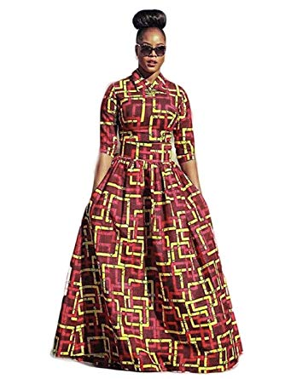

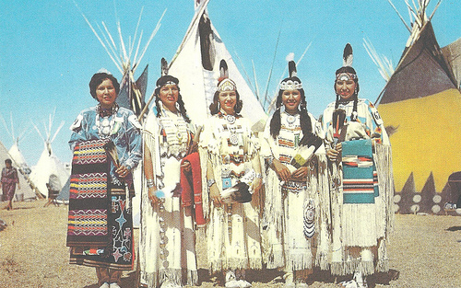

[This Photo](https://www.flickr.com/photos/g-dzilla/3096377410/) by Unknown Author is licensed under [CC BY-ND](https://creativecommons.org/licenses/by-nd/3.0/)

**Theme: “A SISTERHOOD OF RAINBOWS”**

**“You are welcomed to wear attire of your heritage”**

**HOLIDAY INN COLLEGE PARK**

**10000 Baltimore Avenue**

**College Park, MD 20740**

**Saturday, May 4, 2019 – 11:30 a.m. – 2:30 p.m.**

**Registration: Early Bird Donation is $35.00 before April 12th.**

**After April 12th the Donation is $40.00.**

**(The proceeds from this event will assist in sponsoring the current Missioner-in-Residence)**

**Name________________________ Church____________________**

**(List additional names on an attached sheet)**

**Please make check or money order payable to Epworth House**

**Mail to: Jeanette M. Tolbert-Campbell, Treasurer**

**2711 Judith Avenue, Forestville, MD 20747**

**If we can answer any questions please call:**

**Jeanette Campbell, 301-967-6577 or Gertrude White, 301-656-9116**

* **Please do not send cash. We regret we cannot accept walk-ins.**
* **The church with the highest number of members from the eight Districts will be recognized.**