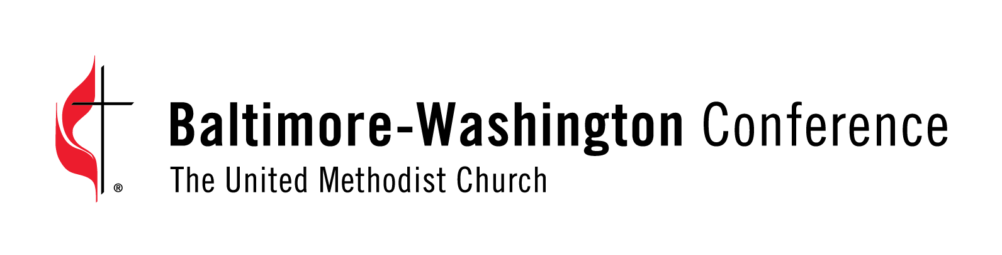

QUALITY OF LIFE HIV RETREATS ..

WORLD AIDS DAY 2020 - GLOBAL SOLIDARITY, SHARED RESPONSIBILITY
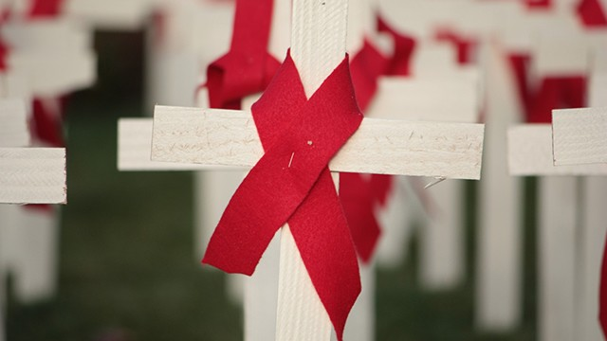

“WHEN COVID-19 CROSSES PATHS WITH HIV”

Every year, on December 1st, the world commemorates World AIDS Day. People around the world unite to show support for people living with and affected by HIV and to remember those who lost their lives to AIDS.

In 2020, the world’s attention has been focused by the COVID-19 pandemic on health and how pandemics affect lives and livelihoods. COVID-19 is showing once again how health is interlinked with other critical issues, such as reducing inequality, human rights, gender equality, social protection and economic growth. With this in mind, the theme of World AIDS Day 2020 is “Global Solidarity, Shared Responsibility”.

Now in our 32rd year of hosting Educational/Spiritual Retreats, Quality of Life Retreats welcomes People Living with HIV/AIDS (PLWHAs) to join us in celebrating World AIDS Day 2020.On November 21, 2020 from 8:45 a.m. to 1:00 p.m., we will be presenting our 2nd in a series of online ZOOMRetreats2020 entitled, “WHEN COVID-19 CROSSES PATHS WITH HIV.”

We are pleased to welcome Todd Brown MD. PhD. a Professor of Medicine and Epidemiology in the Division of Endocrinology, Diabetes and Metabolism at Johns Hopkins University. He will join us in providing an educational update on Covid-19 and HIV.

Dr. Brown has extensive background working in and supporting the HIV Community.
COVID-19 has demonstrated that, during a pandemic, no one is safe until everyone is safe. Leaving people behind is not an option if we are to succeed. Eliminating stigma and discrimination, putting people at the center and grounding our responses in human rights approaches are key to ending the colliding pandemics of HIV and COVID- 19.

After Dr. Brown’s presentation, we will offer time for Q&A and host a Small Group discussion encouraging personal sharing of resilience and positive changes PLWHAS have accomplished in surviving the Covid-19 pandemic. As always, we welcome our founder Rev. Dr. Terri Rae Chattin who will share scripture and offer spiritual guidance as we move into 2021.

This crisis has been a wake-up call, an opportunity to do things differently and better together. In many respects, the defeat of AIDS as a public health threat is critically linked to how the world responds to COVID-19.

The leadership and engagement of communities, instrumental in the success of the AIDS response, has also been key in responding to COVID-19. We have seen countless examples of how community activism and solidarity have, once again, been paramount in providing people affected by HIV with information, services, social protection, and hope.

However, such solidarity cannot be the sole responsibility of communities. Governments, donors, faith leaders, civil society and each and every one of us need to contribute in making the world a healthier place.

Now is the moment for bold leadership for equal societies, the right to health for all and a robust and equitable global recovery. This World AIDS Day join us in stepping up efforts to achieve a healthier society. This World AIDS Day let us demand global solidarity and shared responsibility.

If you are a Person Living with HIV/AIDs and you wish to participate in this ZoomRetreat2020 please contact our Registrar Angel ASAP via email at qualityofliferetreatshiv@yahoo.com or contact us by telephone at 443-440-2312. Space is limited.

20201101_QOLRetreatsEConnectionPressRelease_LCH

