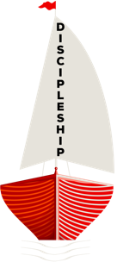
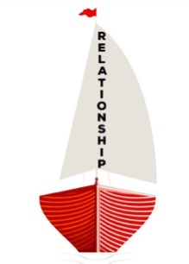
Baltimore-Washington Conference:
We are One: Going out in Mission
Washington East District
“From Relationship… Discipleship”
2020 Virtual Church Conference Agenda
“Cast out your net on the right side of the boat…” John 21:6 (NRSV)
Announcements (Check website & District FB Page for more announcements)
- Nov. 29 – Virtual Advent Worship Celebration
- Dec. 27 – Virtual Christmas Worship Celebration
- Washington East District Virtual Choir debut Jan. 2021; check email to join.
Opening Worship
    - Greeting & Church Roll Call (hands-up when your church is called)
    - Opening Prayer
    - One Missional moment – Lay Leader from each church (2 minutes)
    - One Ministry Goal – Pastor from each church (1 minute)
    - Scripture – John 21:4-6
    - Centering Song
    - Reflection – “Continue Casting your Nets” – DS Cogman
    - Closing Worship Prayer

Churches move into their Zoom breakout room; presiding elder will facilitate.
  - Pastor’s Report (acknowledge receipt)
  - Connected Clergy Report (if applicable, acknowledge receipt)
  - Lay Servant Reports (acknowledge receipt)
  - Nominations Report (voted on in its entirety)
  - Candidates for Ordained Ministry (voted on & vote count documented)
  - Clergy Compensation (voted on in its entirety)
